ATOC5860 – Application Lab #3
Empirical Orthogonal Function (EOF) Analysis

Note: This application lab requires netcdf4 and cartopy packages. Use the culabenv2022clean environment. See included culabenv2022clean.yml file

A reminder of the EOF/PCA Analysis Recipe – 5 steps

1) Prepare your data for analysis. Examples might include:
a) sub-setting the global data to a smaller domain
b) subtract the mean
b) standardizing the data (divide by the standard deviation)
d) cosine weighting (Account for the decrease in grid-box area as one approaches the pole (i.e. weight your data by the cosine of latitude)
e) detrend the data
f) remove the seasonal or diurnal cycle
g) remove NaN – EOF analysis does not work with missing data.

2) Calculate the EOFs and PCs using one of the two methods discussed in class: a) Eigenanalysis of the covariance matrix
b) Singular Value Decomposition (SVD).

3) Plot the first 10 eigenvalues (scaled as the percent variance explained) in order of variance explained. Add error bars following North et al. 1982. Describe how you determined the effective degrees of freedom N*. How many statistically significant EOFs are there?

4) Plot EOF patterns and PC timeseries (usually just the first three or so unless you want to look at more).

5) Regress the data (unweighted data if applicable) onto standardize values of the 3 leading PCs. In other words, project the standardized principal component onto the original anomaly data X to get the EOF in physical units. You should have one regression pattern for each PC – i.e., the EOF pattern associated with a 1 standard deviation anomaly of the PC. Note: The resulting patterns will be similar to the EOFs but not identical.

Notebook #1 – EOF analysis using images of people
ATOC5860_applicationlab3_eigenfaces.ipynb

LEARNING GOALS:
1) Complete an EOF analysis using Singular Value Decomposition (SVD).
2) Provide a qualitative description of the results. What are the eigenvalues, the eigenvectors, and the principal components? What do you learn from each one about the space-time structure of your underlying dataset?

DATA and UNDERLYING SCIENCE:
In this notebook, you apply EOF analysis to a standard database for facial recognition: the At&t database.
https://www.cl.cam.ac.uk/research/dtg/attarchive/facedatabase.html

“Our Database of Faces, (formerly 'The ORL Database of Faces'), contains a set of face images taken between April 1992 and April 1994 at the lab. The database was used in the context of a face recognition project carried out in collaboration with the Speech, Vision and Robotics Group of the Cambridge University Engineering Department.

There are ten different images of each of 40 distinct subjects. For some subjects, the images were taken at different times, varying the lighting, facial expressions (open / closed eyes, smiling / not smiling) and facial details (glasses / no glasses). All the images were taken against a dark homogeneous background with the subjects in an upright, frontal position (with tolerance for some side movement).”

The goal is to think a bit “out of the box” of Atmospheric and Oceanic Sciences about potential applications for the methods you are learning in this class for other applications.

Questions to guide your analysis of Notebook #1:

1) Execute all code without making any modifications. What do the EOFs (spatial patterns) tell you? What do the PCs tell you? How do you interpret what you are finding?
All of the pictures have the same dimensions. Since we have M pictures vectorized into L pixels, the dataset (A) is a L x M matrix. Principal components are eigenvectors ranked on their eigenvalues. They are like keys to reconstruct the faces. The greater the eigenvalue, the more information it has about the matrix A. To conserve space, only a certain number of eigenvectors are kept, only the most important face pictures are kept.

2) Reconstruct a face. How many EOFs do you need to reconstruct a face from the database? Does it depend on the face that it used?
Using a sample size of fifty faces, an average white male face can be reconstructed rather well.

3) Food for thought: The database contains 75% white men (https://www.cl.cam.ac.uk/research/dtg/attarchive/facesataglance.html). How do you think this database limitation impacts the utility of the database for subjects who are not white men? What are some parallels that you might draw when analyzing atmospheric and oceanic sciences datasets? Hint: Think about the limitations of extrapolation beyond the domain where you have data.
By excluding people of color in these databases and accounting for diverse faces, the services provided based on datasets like these are limiting, exclusive, and dangerous to draw conclusions based on.

Although it holds less weight and social importance, atmospheric and oceanic sciences datasets have similarities. For example, global climate datasets often have greater resolution that represents the open ocean under global processes well but not necessarily coastal processes. Additionally, arctic data is scarce, so that must be kept in mind.

Notebook #2 – EOF analysis of Observed North Pacific Sea Surface Temperatures
ATOC5860_applicationlab3_eof_analysis_cosineweighting_cartopy.ipynb

LEARNING GOALS:
1) Complete an EOF analysis using the two methods discussed in class: eigenanalysis of the covariance matrix, Singular Value Decomposition (SVD). Check that they give the same results (They Should!).
Using both methods gave the same results.

2) Assess the statistical significance of the results, including estimating the effective sample size. (Lots more to think about here for estimating the autocorrelation and N* in data…)

3) Provide a qualitative description of the results. What are the eigenvalue, the eigenvector, and the principal component? What do you learn from each one about the space-time structure of your underlying dataset?
4) Assess influence of data preparation on EOF results. What happens when you remove the seasonal cycle? What happens when you detrend? What happens when you cosine weight by latitude? What happens when you standardize your data (divide by standard deviation)? What happens when you compute anomalies?

DATA and UNDERLYING SCIENCE:
In this notebook, you will analyze observed monthly sea surface temperatures from HadISST (http://www.metoffice.gov.uk/hadobs/hadisst/data/download.html). The data are in netcdf format in a file called HadISST_sst.nc. Note that this file is ~500 MB so it might take a bit of time to download. You will subset the data to only look at the North Pacific. Depending on how you prepare your data for analysis – you might expect to see different spatial patterns (eigenvectors) and different time series (principal components). Some things you might look for in your results are the Pacific Decadal Oscillation, “global warming”, the seasonal cycle, …. Depending on your data preparation – your hypothesis for what you should see in your EOF analysis should change. Note: In this dataset - land is NaN, sea ice is -999 – the notebook sets all values over land and sea ice to 0 for the EOF analysis.

Questions to guide your analysis of Notebook #2:

1) Your first time through the notebook – Execute all code without making any modifications. Provide a physical interpretation for at least the first two EOFs and principal components (PC). What do the EOFs (spatial patterns) tell you? What do the PC time series for the EOFs tell you? What do you think of the method for estimating the effective sample size (Nstar)? Can you propose an alternative way to estimate Nstar? Do you get the same results using eigenanalysis and SVD? If you got a different sign do you think that is meaningful?.
EOF1 looks a lot like the North Pacific Gyre, which rotates clockwise, bringing water at the pole down along the western US and water at the equator up along eastern Asia. This makes sense as the primary component as the general ocean circulation is driven by earth’s rotation and general atmospheric circulation. EOF2 looks like a similar patter to the Pacific subpolar gyre. Although not quite as apparent, the signal looks opposite to that in EOF1. EOF analysis breaks up what drives the anomalies and explains it by components. It’s a way to make your data smaller. Since the seasonal cycle has been removed, we shouldn’t see the seasonal cycle in the principal components. This is important because seasonality would likely be an important eigenvector.
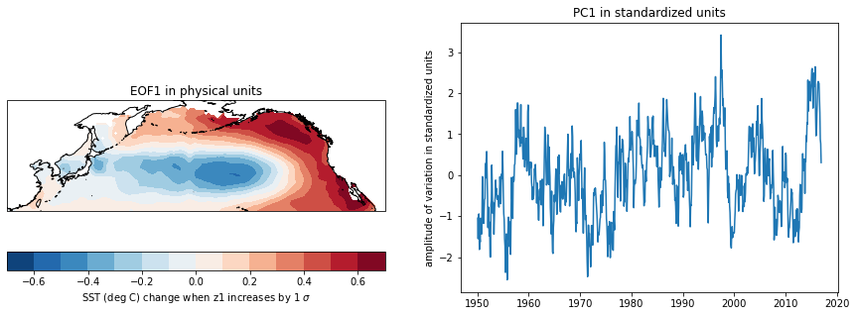
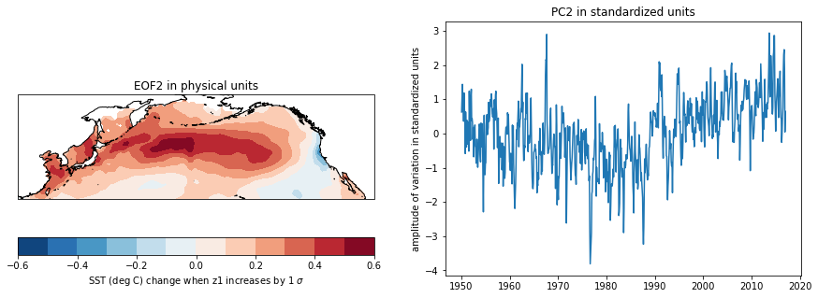
Figure 1. EOF1 and EOF2 of sea surface temperature anomalies and their primary components.
While I don’t have a new method of calculating N*, I think that estimating N8 using the equation from Barnes notes is better than using the mean of the data. I don’t think it’s always a good assumption that all samples are independent. Using smaller N* means we’re being more conservative in our data analysis because as we increase our sample size, we increase the confidence in our confidence intervals.

Although we get the same results using eiganalysis and SVD, they are different signs. However, the signs of the EOF spatial pattern are also swapped, so when multiplied together, they provide the same value. Since the value of the magnitude is conserved, it shouldn’t be meaningful.
2) Save a copy of the notebook, rename it. Repeat the analysis but this time do not remove the seasonal cycle. What do you think you will see? How do the EOFs and PC change? Was removing the seasonal cycle from the data useful? What impacts does removing the seasonal cycle have on your analysis?
Adding in the seasonal cycle, I expect to see this to become EOF1 and explain the largest amount of variance. It’s hard to speak about usefulness because we haven’t identified what we’re looking for. Usefulness is produced from situation. Therefore, removing the seasonal data was neither helpful or unhelpful, but one way of looking at and analyzing the data. Since the amplitude of the principal component is now close to one, it seems that this EOF explains a lot of the sea surface temperature. Removing the seasonal cycle allows us to focus in on other important influences on sea surface temperature.
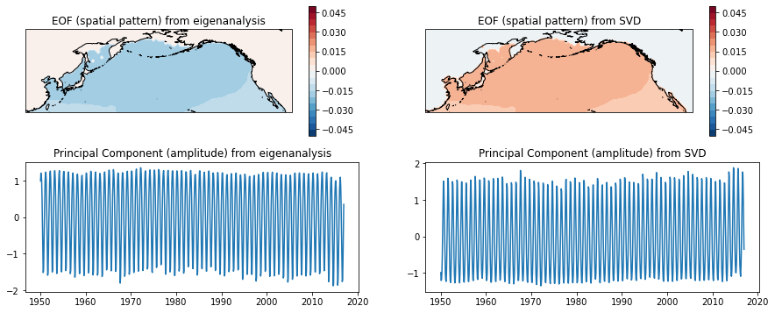
Figure 2. EOF1 of sea surface temperature anomalies and their primary components using eigenanalysis and SVD. Results are inverted, but the same.

3) Save a copy of the notebook, rename it. Repeat the analysis but this time detrend the data. Discuss your results. How do the EOFs and PC change? Was detrending the data useful? What impacts does detrending have on your analysis?
Detrending the data seems to show varying sea surface temperatures between the open ocean and the surrounding area. The circular motion of sea surface temperature does not seem to be present. The magnitude of the primary components is no longer one, which suggests that this EOF isn’t as representative as the EOF with the seasonal trend. We see more variation than in the seasonal cycle. Again, detrending the data was useful to see something new in the data. However, it’s usefulness depends on the question being asked.
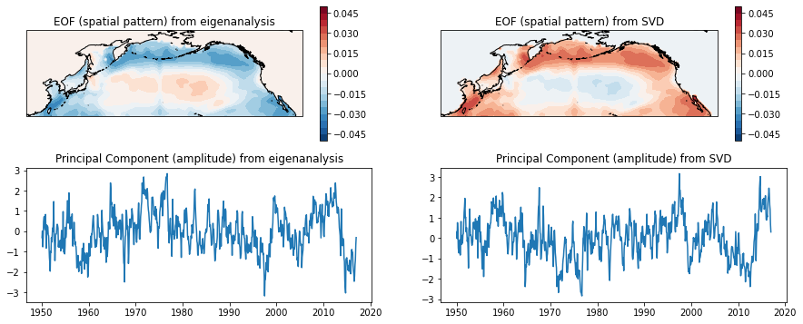
Figure 3. EOF1 of sea surface temperature anomalies and their primary components using eigenanalysis and SVD. Results are inverted, but the same.
4) Save a copy of the notebook, rename it. Repeat the analysis but this time do not apply the cosine weighting. Discuss your results. How do the EOFs and PC change? Was cosine weighting the data useful? What impacts does cosine weighting have on your analysis? What are examples of analyses where cosine weighting would be more/less important to do?
Not applying the cosine weighting doesn’t appear to do anything, but visual depictions can be misleading and not easily analyzed in a cursory glance. Therefore, while it doesn’t visually look important, it’s an important part of preparing data. When thinking about concentration data, it’d be important to apply cosine weighting because concentrations in grid cells would be different between the equator and the pole.
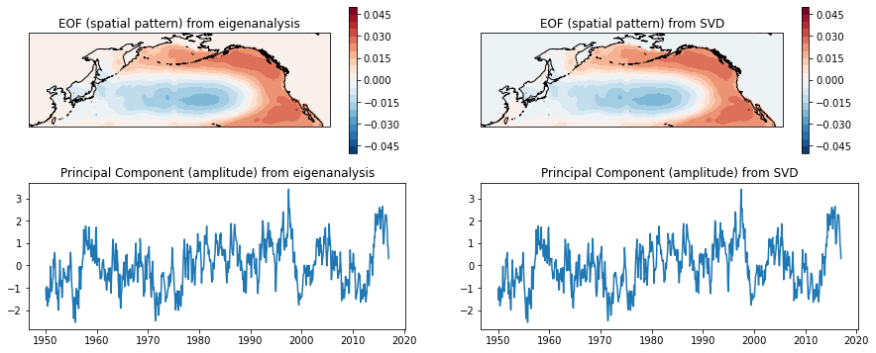
Figure 4. EOF1 of sea surface temperature anomalies and their primary components using eigenanalysis and SVD. Results are inverted, but the same.

4) Save a copy of the notebook, rename it. Repeat the analysis but this time do not standardize the data (i.e., comment out dividing by standard deviation). Discuss your results. How do the EOFs and PC change? Was standardizing the data useful? What impacts does standardizing the data have on your analysis?
Standardizing the data does have slight visual changes to the EOF. It’s easier to see in the spatial dimension than in time. Standardizing the data is another way to look at the data, but makes it easier to compare to other data.
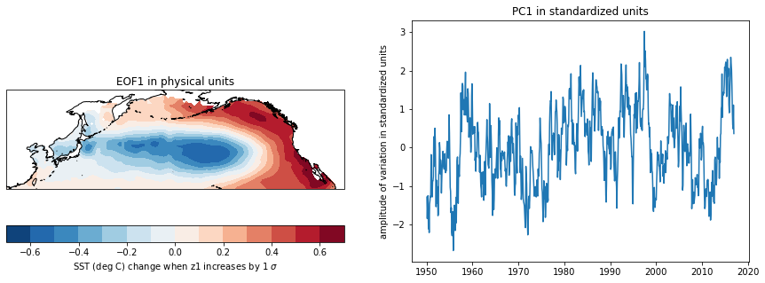

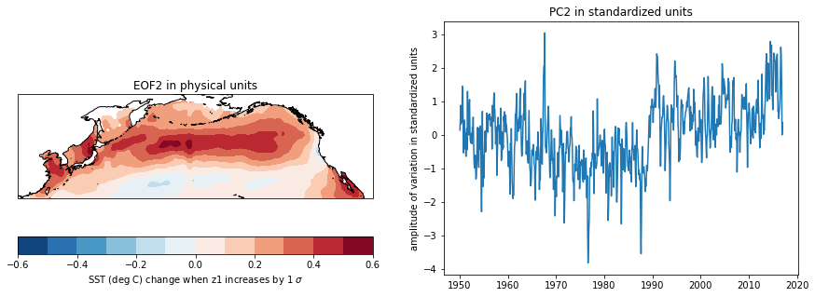
Figure 5. EOF1 of sea surface temperature anomalies and their primary components using eigenanalysis and SVD. Results are inverted, but the same.

